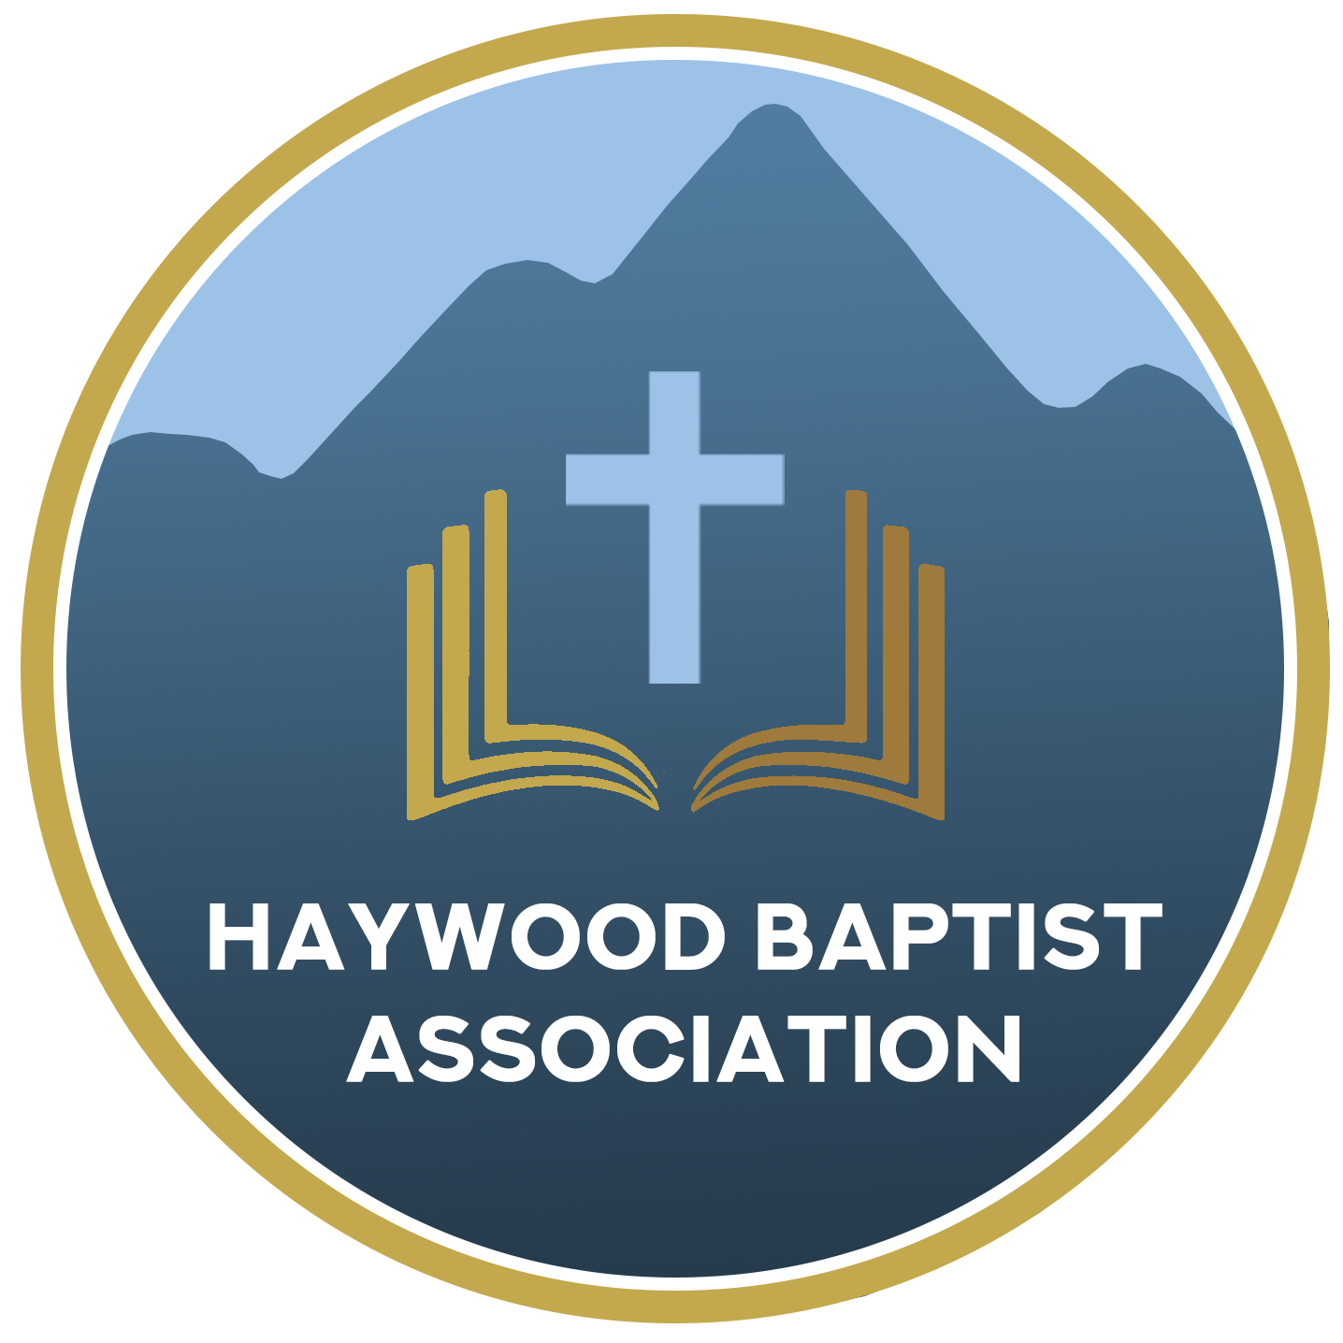
Haywood Baptist Association
Weekly E-News
August 24, 2022

CANTON LABOR DAY FESTIVAL – MISSION OPPORTUNITY!

The Canton Labor Day Festival is September 4th-5th, and we need YOUR help! We will need to staff this event beginning after church on Sunday, the 4th, as it gets underway at noon. We will also need to set up some on Saturday. The first night ends at 9:30PM and it all cranks back up at 10:00AM on Labor Day, and we will need to tear down that evening after supper.

We would love for your church to get involved! You can wear t-shirts promoting your church if you have them. We plan to have an inflatable waterslide. There will be a first-aid station where we can use medical personnel to staff. Also, we will offer a baby-changing and feeding tent. Giving out water, balloon yo-yos, and salvation bracelets for the kids are planned. If you would like to do face painting, we would be glad to offer that!

Thousands of people will attend Canton’s huge Labor Day Festival. As an association, we have been given an amazing opportunity to be a light for our community during this event! HBA would like for our churches to come together as one and serve the community during this event. We want to staff the children’s play area with volunteers from every church. We have made a list of volunteer opportunities that we need to be filled within this event.

We live in a time with broken homes, addictions, and so much rampant despair. Canton’s Labor Day Festival is the perfect chance for all HBA churches to show Christ and witness to our community.

Please call the HBA office at 828-452-4746 with any questions and to get your church signed up to volunteer for this event. We look forward to hearing from you soon!
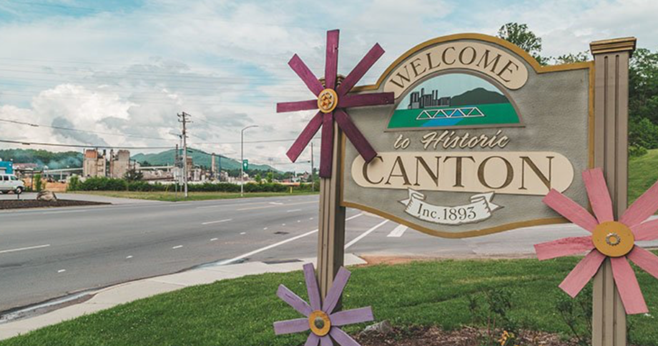

Our AMS Dennis Thurman is inviting everyone to
join him in prayer for our Churches and Pastors:

- Antioch- Chris Wilmoth
- Barberville- Kris Estep
- Beaverdam- Gene Worley

PRAY FOR UKRAINE!

Here is a prayer update from Baptists on Mission concerning Ukraine. Follow the link:

https://baptistsonmission.org/ukraine-crisis

IMPORTANT INFORMATION!
MEN’S PRAYER MEETING
We have a prayer meeting at the Associational Office at 7 AM Tuesdays for a time of focused prayer. Pastors, staff, and other men are invited. We will pray for the churches, we will pray through Scripture texts that and asking for God to guide our ministry for the week and bring anointing in our messages, music, and mission.

Employment Opportunities.
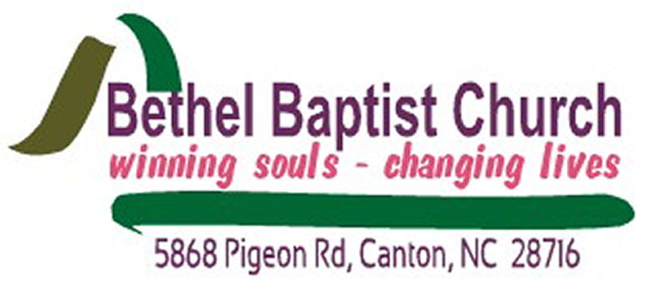

Bethel Baptist Church, Canton, NC is seeking a children’s minster. The children’s minister should have a love for God, children, and desire to see children grow spiritually. In this ministry, some of the responsibilities would be leading Sunday morning Children’s church, including worship, children’s sermons, music, leading Sunday night Children’s worship time, and being active in and coordinating children and parents’ outreach and visitation. This person will work closely with the leadership of Bethel Baptist.
Please submit resumes by mail or email to:
Mail: Bethel Baptist Church
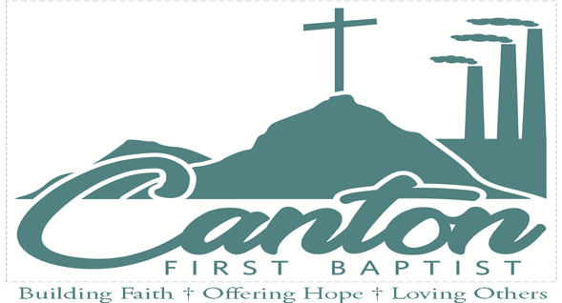
Attention: Amy Warren, Secretary
5868 Pigeon Rd
Canton, NC 28716
Email: Bethelbaptist08@yahoo.com

Church Financial Secretary. Part-Time position (approx. 20 hours per week). Responsibilities: work with church counter on offerings and deposits, post receipts and disbursements of all accounts according to financial systems, pay bills, process pay-checks, prepare financial reports to forward to church treasurer and finance committee, prepare monthly and annual financial reports for Finance Committee and other committees of the church, meet with Finance Committee monthly, assist in planning and promoting stewardship campaigns and audits as necessary. Send Resume to cfbc202@gmail.com. Thank you!

Susan C. Davis
Church Admin.
cfbc202@gmail.com

208 Academy Street
Canton, NC 28716
828. 648.2367

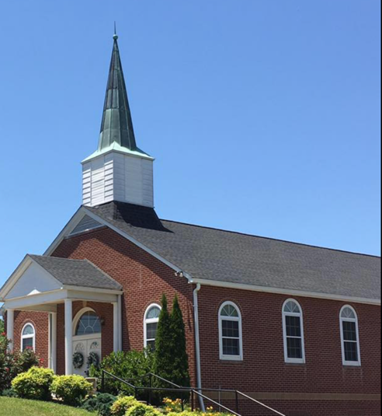
North Canton Baptist Church

North Canton Baptist Church is looking for a Song/Praise Leader. If you are interested, please contact Pastor Marty Nelson at: pastormartynelson@gmail.com

Pinnacle Church is hiring a position in student ministry. This would be to lead the middle school and high school ministries full time. For more information and to apply, please visit: https://pinnacle.elexiochms.com/external/form/34b86081-50b8-4406-9c2e-0a27bb9d37fa

Coats for the City shares the love of Jesus by providing warm coats and the gospel to residents of New York City each December. North Carolina Baptists have partnered with the Metropolitan New York Baptist Association (MNYBA) in this effort for eight years. Working with churches across New York City, we desire to distribute coats along with a Bible or Jesus film in the language of every recipient.

To learn more about this project, please visit:

https://ncbaptist.org/events/event-coats-for-the-city/

Pisgah Baptist Camp Meeting 2022
September 12th – 16th
7:00PM
Calvary Road Baptist Church
2701 Soco Rd.
Maggie Valley, NC 28751

Evangelist: Timmy Blair
Special Music: Brought by Pastors Choir, Calvary Road Choir, Crestview Choir, and others to be announced.

For more information, contact:
Walter Brooks at 828-734-6110.

Riverside Baptist Church will be celebrating its 100-year Anniversary, August 28, 2022 @ 10:00AM, at their Annual Homecoming. For more information, please call the church office at 648-4709.

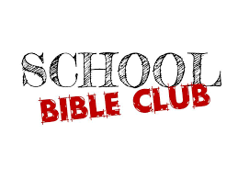

The Haywood County Bible Clubs will soon be meeting in our elementary schools.
We have seen God's hand working in many children's lives and the lives of the families. Consider supporting the clubs by volunteering to help, donating prepackaged snacks, becoming a prayer partner: there are many ways to serve! Please contact Charles and Barbara Biera for more information. 828-421-0811
Bethel Elementary Club needs leaders/helpers- the club meets on Thursday afternoons Please call Amy Warren 828-246-2732

