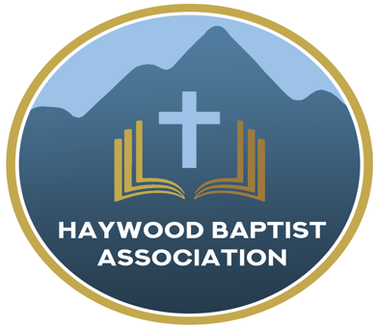
Haywood Baptist Association
Weekly E-News
September 28, 2022

Is The Word of God Enough?

"All Scripture is given by inspiration of God, and is profitable for doctrine, for reproof, for correction, for instruction in righteousness, that the man of God may be complete, thoroughly equipped for every good work." (2 Timothy 3:16-17 NKJV)
Baptists settled our conviction concerning the authority of Scripture in a battle for the Bible back in the early days of my ministry. If you asked the typical Southern Baptist preacher today, "Is the Word of God inerrant?" they will give you a resounding, "Amen!" Yet, if you listen carefully, you will begin to wonder if we believe the Word of God is sufficient. It is authoritative, but is it adequate? Must we add gimmicks and dress truth up in worldly garb? Churches seem to always be searching for the latest innovation that will be the magic pill for having a megachurch! I mean, why carry the Ark of the Covenant on the shoulders of priests, when you can tote it in an ox cart? What could go wrong? I mean, the pagan Philistines had done it (1 Sam.6), so why not the Israelites? Read 2 Samuel 6 and see!
One may not hear a preacher say that Scripture is insufficient, but more often what is unsaid. Bible truths are faithfully preached--a text taken, and a message delivered--dealing with love, joy, hope, purpose, and so forth. That's Biblical! Yet, while much might be said about heaven, the uncomfortable doctrine of hell is omitted. Subjects like holiness and sanctification are scarce in sermons, it seems. We don't want to offend, so we say to our brothers and sisters in Christ, "We believe all the Bible!" Yet, we say to the world, "God is nice and we are nice. You can come as you are and be comfortable. None of that hellfire and brimstone stuff!"

Certainly, there is to be a balance. Paul said to speak the truth in love (Eph.4:15). Truth without love is harsh and uses the Bible for a club. Love without truth is soft and uses the Bible as a pillow. We must have both, and we will if we truly believe in the sufficiency of Scripture.

I want to encourage you to attend a conference on "The Sufficiency of Scripture," at Fruitland Baptist Bible College next Monday. It begins at 1:30 PM and ends at 8 PM. Dinner will be served, but you need to go online and make a reservation. Here is the link, https://ncbaptist.org/events/the-sufficiency-of-scripture-bible-conference/

We will not have Pastor's Conference at the HBA next week but hope the pastors will attend Fruitland's seminar. If you have any questions call me. If you desire to carpool, contact Mark Tice, the Pastor's Conference President, and plans can be made accordingly. I will meet you there, God willing.

For Standing Tall and Speaking Truth,
Dennis Thurman, AMS

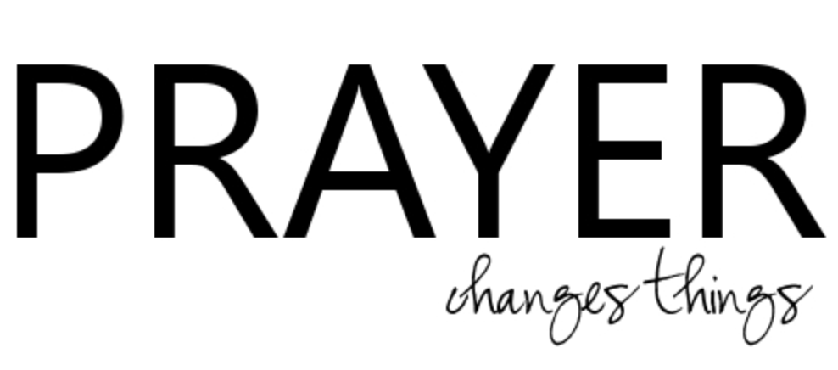

Our AMS Dennis Thurman is inviting everyone to
join him in prayer for our Churches and Pastors:
- Crestview- Dan Page
- Dellwood- Bobby Rogers
- Dutch Cove- Jason Miller

PRAY FOR UKRAINE!

Here is a prayer update from Baptists on Mission concerning Ukraine. Follow the link:

https://baptistsonmission.org/ukraine-crisis

IMPORTANT INFORMATION!

MEN’S PRAYER MEETING
We have a prayer meeting at the Associational Office at 7 AM Tuesdays for a time of focused prayer. Pastors, staff, and other men are invited. We will pray for the churches, we will pray through Scripture texts that and asking for God to guide our ministry for the week and bring anointing in our messages, music, and mission.
Employment Opportunities.

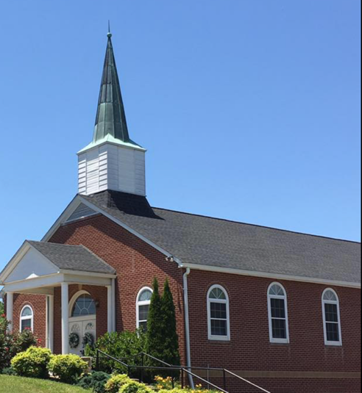
North Canton Baptist Church

North Canton Baptist Church is looking for a Song/Praise Leader. If you are interested, please contact Pastor Marty Nelson at: pastormartynelson@gmail.com

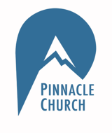
Pinnacle Church is hiring a position in student ministry. This would be to lead the middle school and high school ministries full time. For more information and to apply, please visit: https://pinnacle.elexiochms.com/external/form/34b86081-50b8-4406-9c2e-0a27bb9d37fa

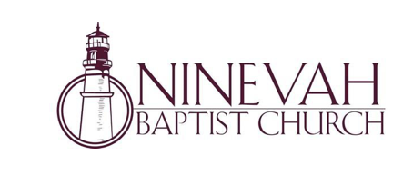

Ninevah Baptist Church is accepting resumes for a part time director of Music Ministries. If interested, please send resumes to PO Box 38. Waynesville, NC 28786.

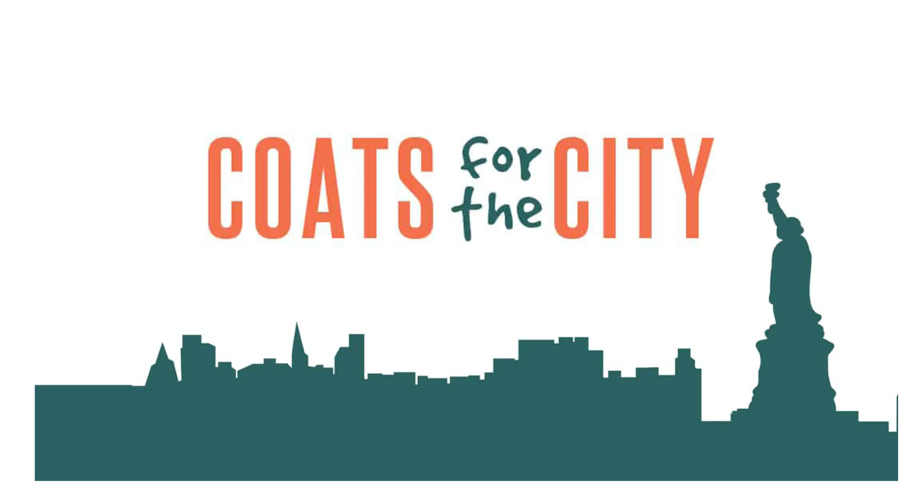

Coats for the City shares the love of Jesus by providing warm
coats and the gospel to residents of New York City each December. North Carolina Baptists have partnered with the Metropolitan New York Baptist Association (MNYBA) in this effort for eight years. Working with churches across New York City, we desire to distribute coats along with a Bible or Jesus film in the language of every recipient.

To learn more about this project, please visit:

https://ncbaptist.org/events/event-coats-for-the-city/

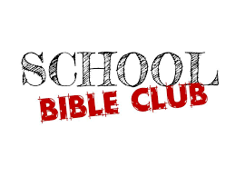

The Haywood County Bible Clubs will soon be meeting in our elementary schools.
We have seen God's hand working in many children's lives and the lives of the families. Consider supporting the clubs by volunteering to help, donating prepackaged snacks, becoming a prayer partner: there are many ways to serve! Please contact Charles and Barbara Biera for more information. 828-421-0811
Bethel Elementary Club needs leaders/helpers- the club meets on Thursday afternoons Please call Amy Warren 828-246-2732

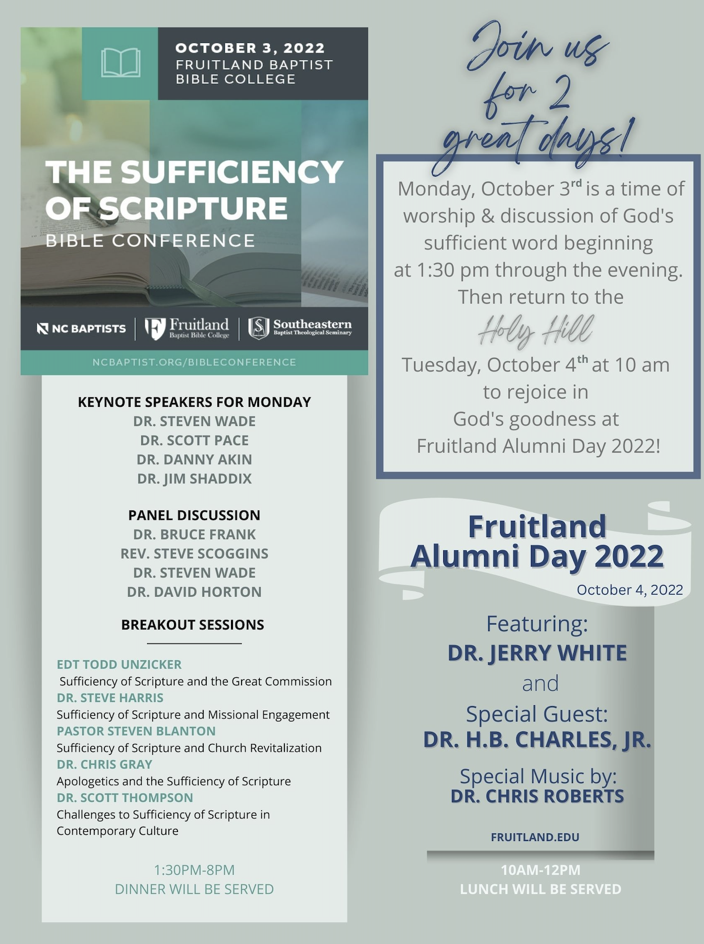

For more information, follow the link in the article!

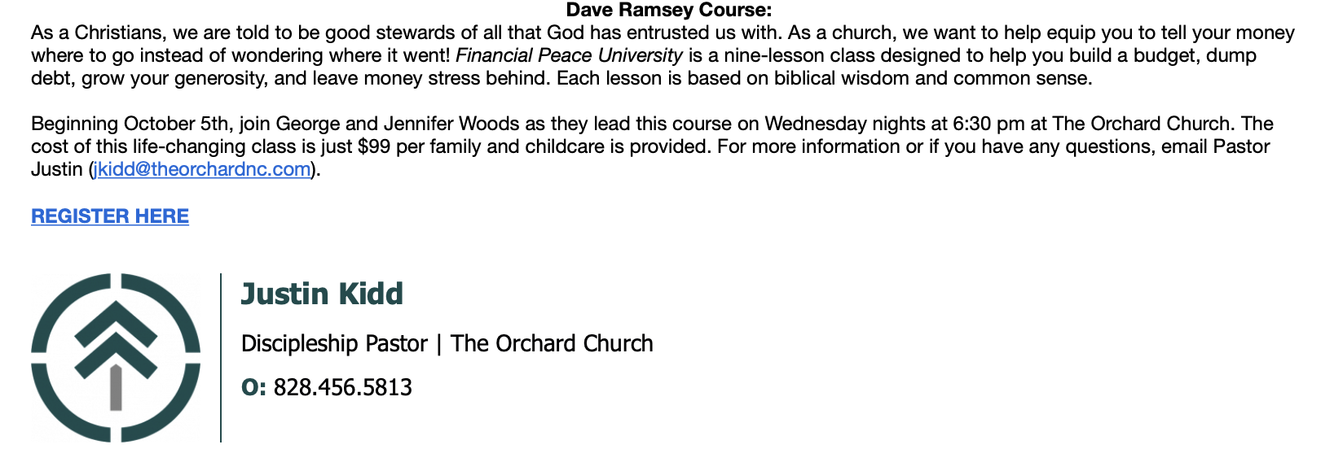

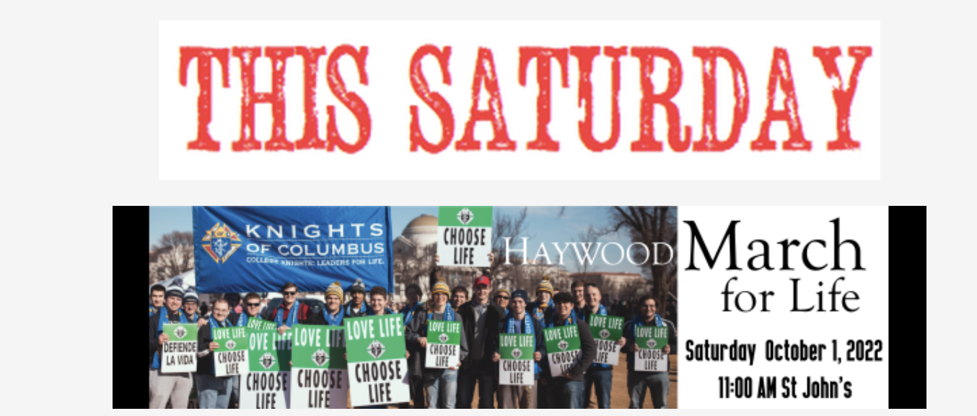
The March for Life Walk will be THIS SATURDAY, October 1st at 11:00AM. Here is the link for more information: https://mailchi.mp/19cdc0d45937/respect_life-5678287

Life Chain Event will be THIS SUNDAY, October 2nd from 2:00-3:00. Participants will stand in silence and pray along the sidewalk of Russ Ave. This is a great opportunity to take a stand for life! Signs will be available at 1:45 in the Wells Fargo parking lot.

